Date: January 8, 2026
To: Fleet Operations Team
From: Mohamed Naveeth
Subject: Why One Tanker Burned Way More Fuel Than Usual – And What It Means for Us
We've been digging into the 2025 dataset from our Nigerian coastal operations (1,440 trips across 120 vessels). The goal was to find any weird standouts in fuel use and figure out if they're real issues or just bad data. Here's what we found, explained in plain terms.
The Outlier We Spotted
We looked at fuel used per distance traveled (like miles per gallon, but for ships) to spot inefficiencies that aren't just from longer trips. Focusing on our tanker ships (the big ones carrying oil), the average is about 40 units of fuel per distance unit.
The clear winner for "most inefficient" is vessel NG077 in June. On a 351-unit trip from Lagos-Apapa:
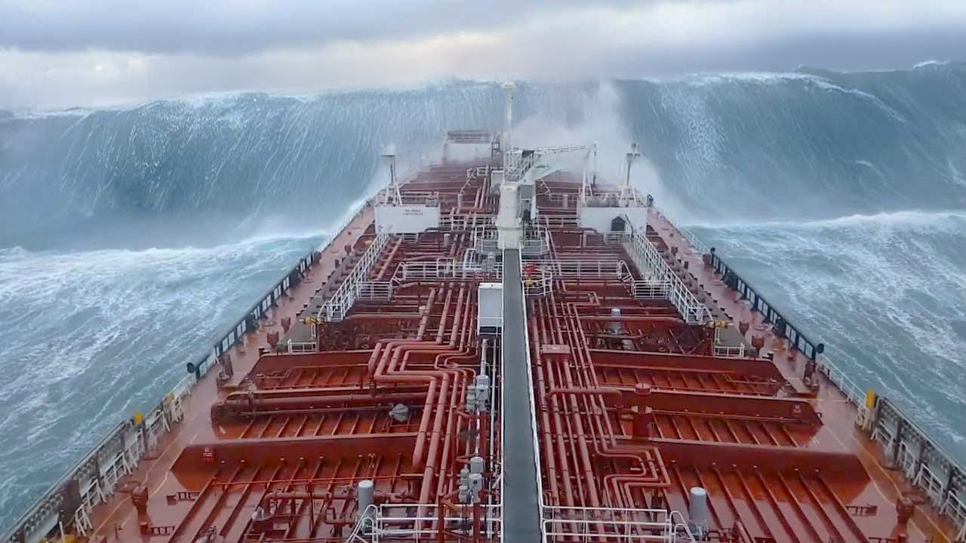
youtube.com
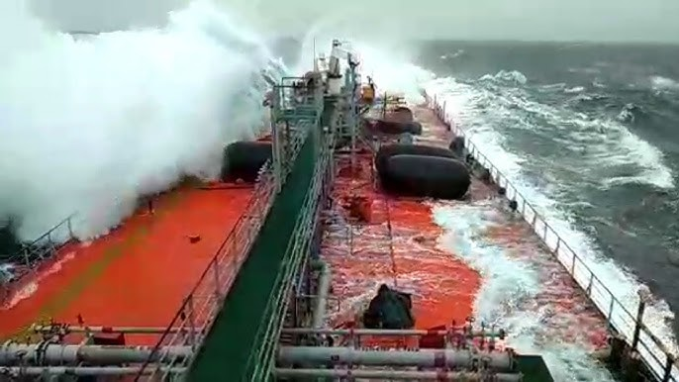
youtube.com
- It burned 17,549 units of diesel – that's nearly 50 units per distance (25% above the tanker average).
- CO₂ emissions hit over 50,000 kg for that single trip.
- Weather: Stormy (the roughest category in our data).
- Engine efficiency: Normal (83%, nothing broken).
This isn't a typo – the numbers check out consistently.
What's Really Going On? (The Physics Behind It)
Bad weather like storms doesn't just make the ride bumpy; it forces the ship to fight harder against the water and wind.
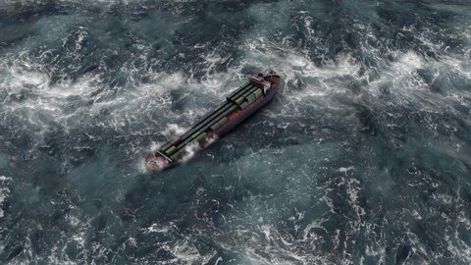
shutterstock.com
Cargo Ship Containers Stormy Oceanaerial Viewsailing
- Big waves and wind create extra drag – the ship has to push through taller, choppier water, like driving a car into a strong headwind but way worse.
- Studies show stormy seas can bump up fuel needs by 30-50% or more, especially for large tankers with high sides catching wind.
- Captains often adjust course or speed to avoid the worst pounding, which adds even more fuel burn.
We also considered hull biofouling (barnacles and slime growing on the hull, making it rough like sandpaper).
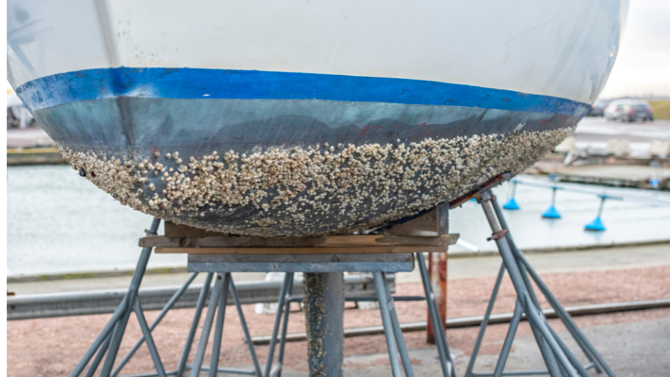
blueatlasrobotics.com

prop-one.com
This can add 20-40% drag over time, but it's gradual. Here, the spike ties directly to one stormy trip, not a slow buildup.
Another possibility: parametric rolling, where waves sync with the ship's natural roll, causing extreme swaying.
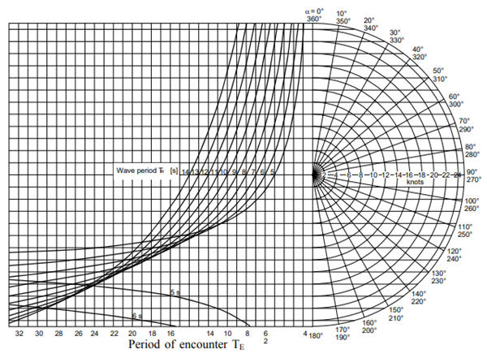
safety4sea.com
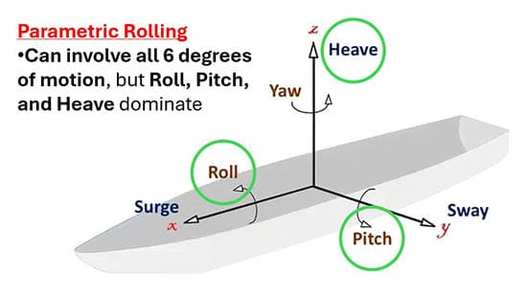
marinepublic.com
This forces speed reductions for safety, burning more fuel overall. Tankers are vulnerable in following seas.
Bottom line: This is real physics at work – stormy weather hammered this trip's efficiency.
Takeaways for the Fleet
Outliers like this remind us weather is a huge variable in fuel costs and emissions. We should:
- Factor storm adjustments into performance benchmarks.
- Prioritize hull cleaning schedules to fight biofouling.
- Use better weather routing tools to dodge rough patches.
Spotting these helps us save fuel, cut emissions, and keep operations smoother.

